LAB ASSIGNMENT-3

-- 1.

SELECT TO_CHAR(SYSDATE)FROM DUAL;

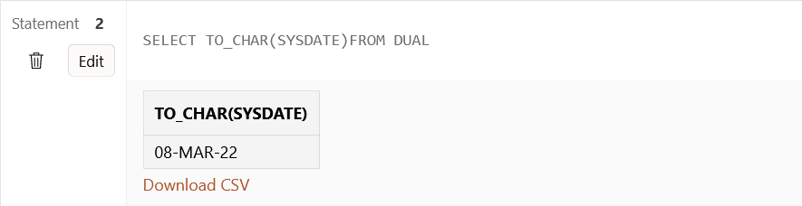

-- 2.

SELECT TO_CHAR(SYSDATE, 'DAY') FROM DUAL;

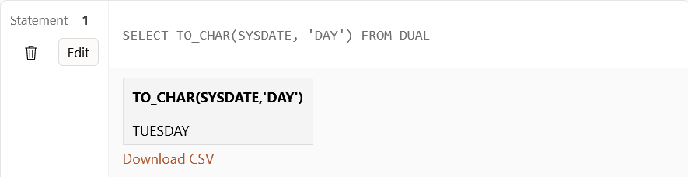

-- 3.

SELECT TO_CHAR(SYSDATE, 'MONTH YEAR') FROM DUAL;

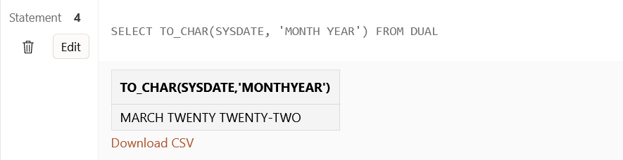

SELECT TO_CHAR(SYSDATE, 'MM YEAR') FROM DUAL;

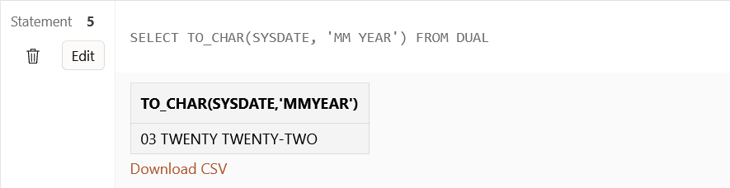

-- 4.

SELECT TO_CHAR(SYSDATE,'DDSP MONTH YEAR') FROM DUAL;

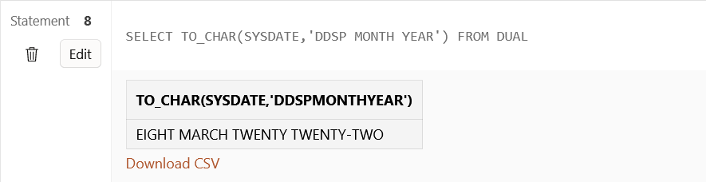

-- 5.

SELECT TO_CHAR(SYSDATE,'PM') FROM DUAL;

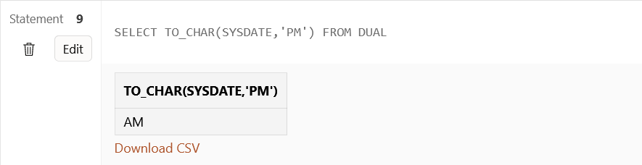

-- 6.

SELECT NEXT_DAY(SYSDATE, 'FRIDAY') FROM DUAL;

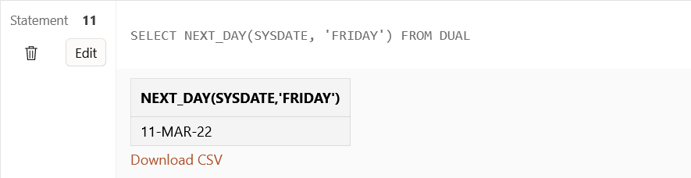

-- 7.

SELECT ROUND(SYSDATE,'MONTH') FROM DUAL;

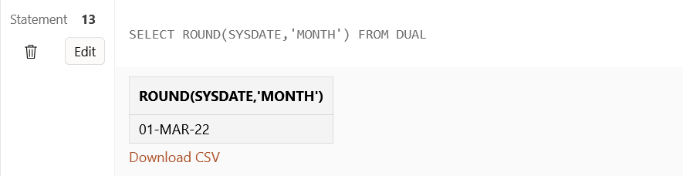

-- 8.

SELECT TRUNC(SYSDATE,'MONTH') FROM DUAL;

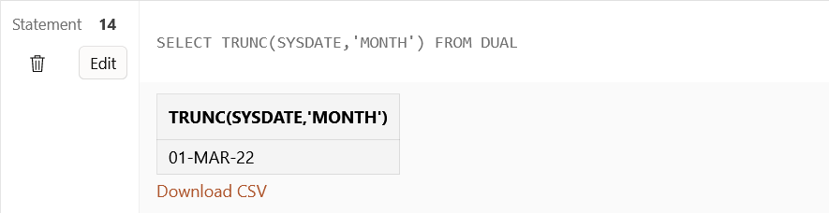

-- 9.

SELECT ROUND(SYSDATE,'YEAR') FROM DUAL;

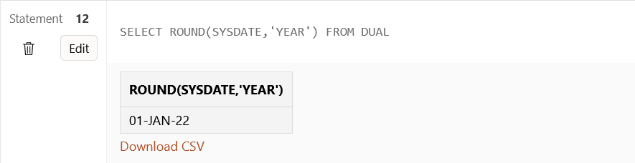

-- 10.

SELECT TRUNC(SYSDATE,'YEAR') FROM DUAL;

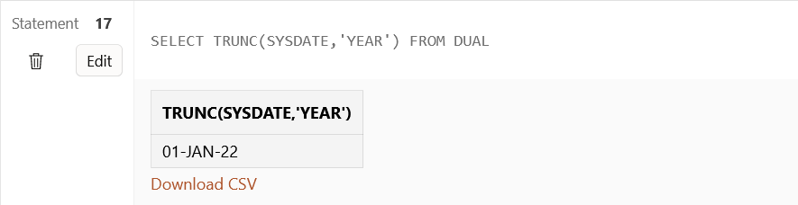

-- 11.

SELECT TO_CHAR(SYSDATE+3,'DAY') FROM DUAL;

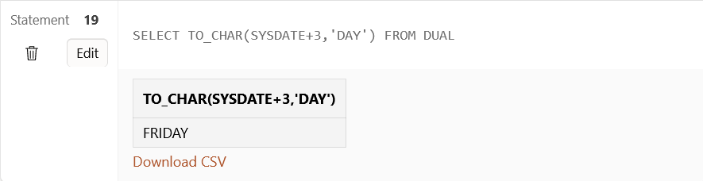

CREATE TABLE emp(ename varchar2(20),doj date)

INSERT INTO emp VALUES('Harshita',DATE '2022-03-07')

INSERT INTO emp VALUES('Soumya',DATE '2022-03-01')

INSERT INTO emp VALUES('Hana',DATE '2022-02-20')

INSERT INTO emp VALUES('Jenna',DATE '2022-03-15')

INSERT INTO emp VALUES('Lenny',DATE '2021-03-07')

INSERT INTO emp VALUES('Kia',DATE '2021-12-28')

INSERT INTO emp VALUES('Harshita',DATE '2022-02-28')

INSERT INTO emp VALUES('Harshita',DATE '2022-03-01')

SELECT * FROM emp

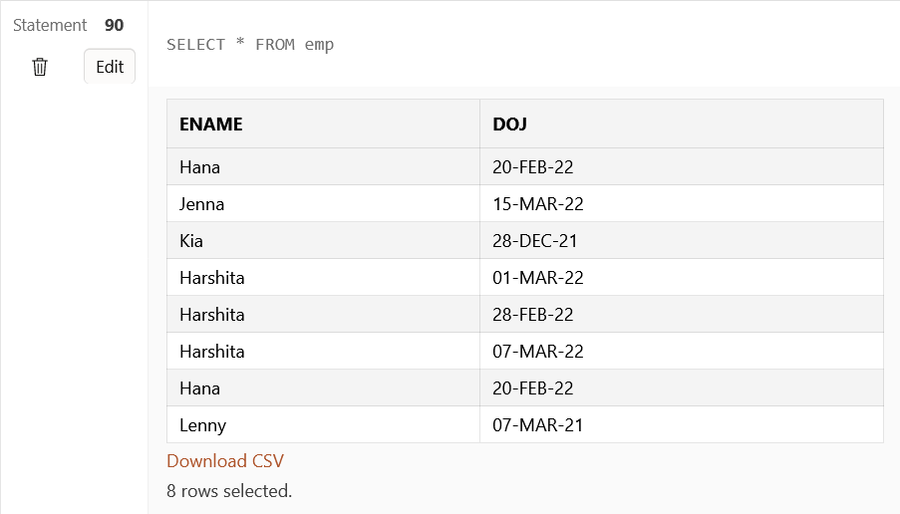

-- 12.

SELECT to_char(doj,'Day') DayOfJoining FROM emp

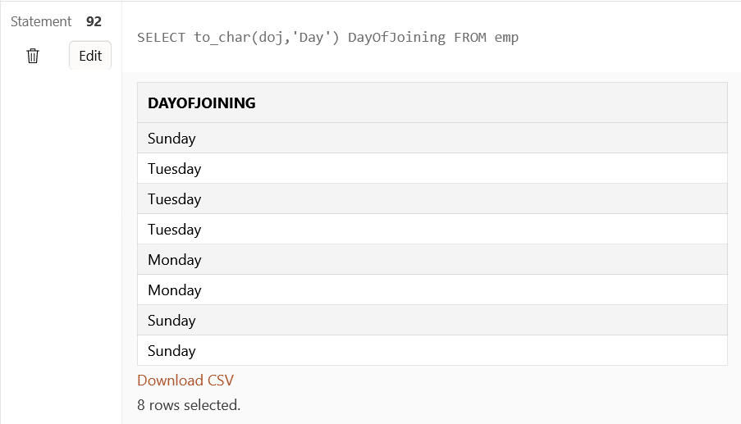

-- 13.

SELECT * FROM emp WHERE trim(to_char(doj,'Day'))='Monday'

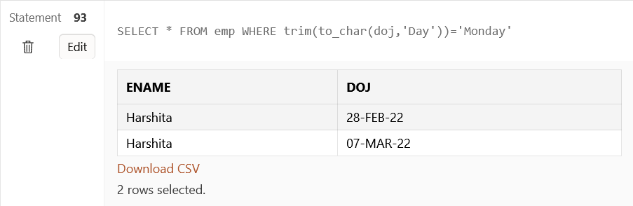

-- 14.

SELECT * FROM emp WHERE to_char(sysdate,'mm')=to_char(doj,'mm')

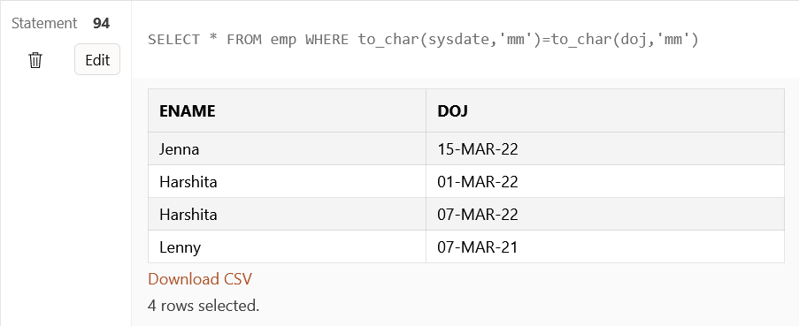

-- 15.

SELECT * FROM emp WHERE sysdate-doj<=30

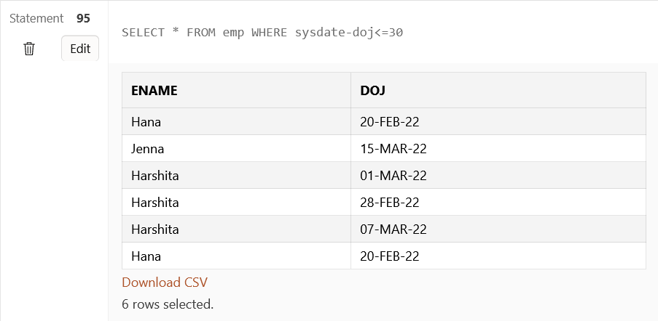

-- 16.

CREATE TABLE train(trno number,dod date, tod timestamp, toa timestamp)

-- 17.

INSERT INTO train VALUES(1,'01-MAR-2022','01-MAR-2022 08:30:00 AM','01-MAR-2022 05:00:00 PM')

INSERT INTO train VALUES(2,'19-FEB-2022','19-FEB-2022 08:00:00 PM','20-FEB-2022 10:00:00 AM')

INSERT INTO train VALUES(3,'27-FEB-2022','27-FEB-2022 07:30:00 AM','27-FEB-2022 03:00:00 PM')

INSERT INTO train VALUES(4,'28-FEB-2022','28-FEB-2022 11:30:00 PM','01-MAR-2022 07:00:00 AM')

INSERT INTO train VALUES(5,'19-MAR-2022','19-MAR-2022 12:30:00 PM','20-MAR-2022 05:00:00 PM')

-- 18.

SELECT * FROM train

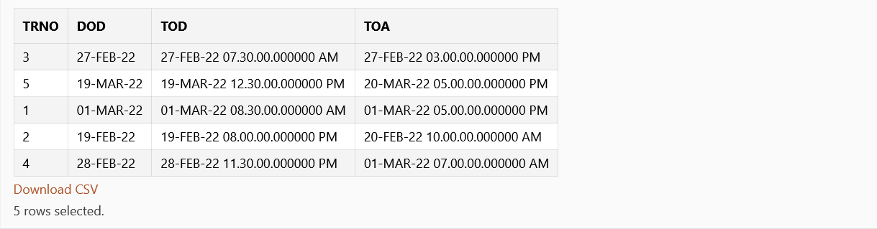

-- 19.

SELECT to_char(tod,'HH-MI-SS') "Time of Departure",to_char(toa,'HH-MI-SS')

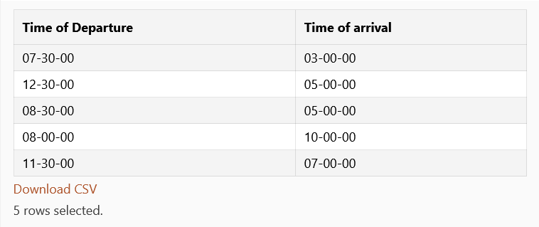

-- 20.

SELECT * FROM train WHERE to_char(toa,'PM')='PM'

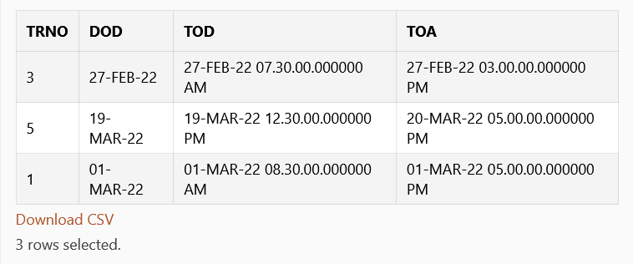

-- 21.

SELECT trno FROM train WHERE tod BETWEEN SYSDATE AND SYSDATE+1/24

